Name:  Teacher : | ____________________________________  ______________________ |  | Date:_________
 | Year 12 Foundations  /28  Time  Full working out MUST be shown to get full marks for each question.
Total Time: | 40 minutes
Weighting: | 5%
Equipment: | Pen, pencil, ruler, scientific calculator, open book.

Question 1 10 marks (2, 2, 2, 2, 1, 1)

How many hours and minutes between:
(a) 10:00 a.m. and 5:30 p.m.? |  | (b) |  |  |  | 8:35 a.m. and 5:15 p.m.?

Write each of the following times using both 12-hour and 24-hour time:

(c) (d)
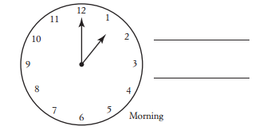 |  |  |  |  |  |  |  |  | 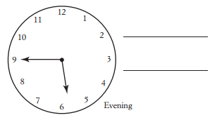

Write each of the following in 12-hour time, using numbers:
(e) ‘twenty-five minutes after one’ in the morning |  |  |  |  |  | (f) |  |  | ‘ten minutes before three’ in the afternoon

Question 2 6 marks (2, 2, 2)
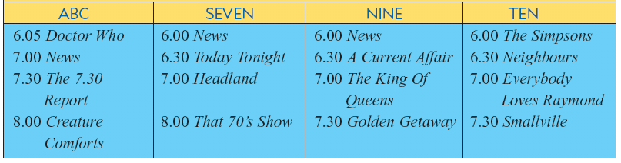
- At what time do the following programs  begin? |  |  |  |  |  |  |  | (b) How long are each of the following programs?
- Neighbours |  |  |  |  |  |  |  | - Doctor Who
(ii) Creature Comforts |  |  |  |  |  |  |  | (ii) The Simpsons
- If you just finished watching Doctor Who, how long do you need to wait to see that 70’s Show?

Question 3 4 marks (2, 2)
Determine the required time for each of the following.
- 35 minutes after 4:19 pm |  |  |  | - 43 minutes before 8:10 am

Question 4 8 marks ( 2, 2, 2, 2)

The table below gives the heights and times of high and low tides for several days over 3-month period.
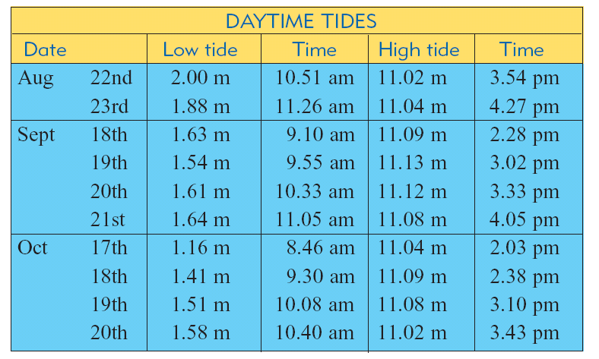

- On 19th September what is the height of the high tide and when does it occur?

- On 18th September:
- When do the low and high tide occur? |  |  | (ii) |  | What is the time difference between the low and the high tide?
- Emily believes that it is best to go fishing half an hour after a high tide. If this is true what would be the best time to go fishing on October the 18th ?

END OF ASSESSMENT

